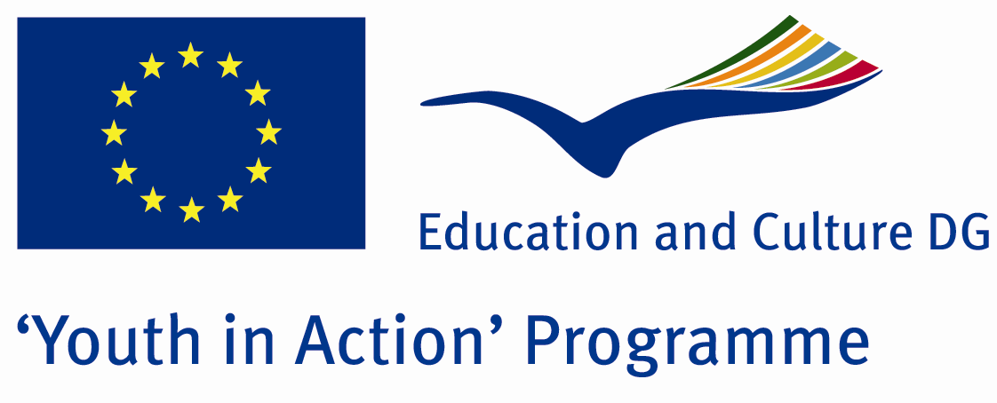

Fire And Ice



ACTION 4.3 – TRAINING AND NETWORKING

01-07th August, 2011

Yalova, TURKEY

ACTION 4.3 – TRAINING AND NETWORKING
01-07th August, 2011
Yalova, TURKEY

Please contact directly to;
adventurerpeacepigeons@gmail.com

Project Summary; Global warming! 30 years Ago, nobody thought about this word..With global warming, the ecoclimate is broken and it caused too many problems and that is why the human started to interrogate this word.Thw world is 4567 bilions years old and the population of it is 7.5 bilions..It is getting more.With economical reasons, like industry, sera gas .e.t.c , it became worse.In 21th century, most of the scientists are searching for solution about this subject.And they think that until 2025, half of world will face to face with famine…

In this Project, we will talk about global warming reasons, some solutions and as people what should we do?And moreover, friendship, to have fun and cultural Exchange..

If you want to join this Project, please contact with us.

Project Title; Fire And Ice

Date and Venue ; 01-07th August, 2011 Yalova, Turkey .

Target Group ; Municipalities, City Councils and Non-Governmental organizations,
youth groups,culture and art groups,e.t.c

Participants ; 5 people from each country (over 18 -25 ). Totally 8 countries.

Conditions ; Accommodation, board and programme costs will be financed through European Commission Youth in Action Programme (Action 4.3). Travel costs will be reimbursed in 70% (APEX Tarrifs). Organizations from all 27 EU member countries plus Liechtenstein , Norway and Iceland are eligible to take part.

Working language: English

Organizer; Discovery And Adventure Group

How to apply: If you are interested, please send your Part III forms to
0090 216 483 21 67 by FAX please. (Fulfilled Part III which you can find in the attachment, of course signed and stamped) ..

Note: jpeg is not allowed..please send by fax…

Next step 2;
Original send via regular post to this address please:

Ertan DERİN
Öner İnşaat
Abdulhalik Renda Cd.
Parlar Sk. No:4 Pendik/İSTANBUL

If you have any questions you may contact with: adventurerpeacepigeons@gmail.com

Deadline for application; until 20th January 2011.

For Further information:
Contact Person
Ertan DERİN
Öner İnşaat
Abdulhalik Renda Cd.
Parlar Sk. No:4 Pendik/İSTANBUL

e-mail : adventurerpeacepigeons@gmail.com
Mobile : 0090 542 393 93 90
Fax : 0090 216 483 21 67

